

ONE TIME STATEMENTS

<Apex/Group/Operational> Layer

Document Version / Details: Ver. 2.0/ 14-Nov-2022

WORD DOCUMENT

New Project Setup: INFRA.

Give relevant Project Name

Choose the database like snowflake

Configure the environment

Create a security integration : This is a one time process which we already did for both the snowflake accounts.

Manage Repository:

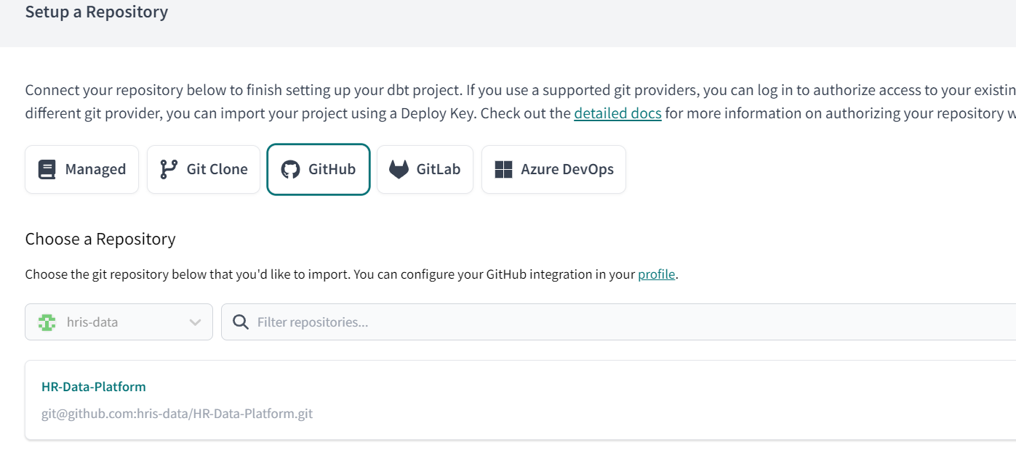

After all these setups, you can get into the DBT developer page then checkout your developer branch.

Created branch as “infra” and checkout in dbt repository. In this branch we have created with infra folder and followed with dbt folder. In the project setup, you have to mention the dbt initialization needs to apply under which folder. Here I have given infra/dbt.

After dbt initialization, the required dbt folder will create like below,

If any new subject area pitch in like lrn,pmgm,ec,cmp,pm,sdds. We have to be in position to create the database and schema with corresponding database and technical role creation. Once you are ready with the scripts, just create file under macros like below,

{% macro create_grant_db_final() %}

---- Replace your command with custom scripts and create the file.--

< custom scripts >

{% endmacro %}

we have the main_macro file which will trigger the sql commands macro.

If you want to run any statements just create one file under macro, and keep the unique name of the macro.  
Give the unique name in the main macro.

1st screenshot name and 2nd screenshot name should match.

Project Name

Then just trigger the job in this project based on the DV,QA,NP and PD regions.

